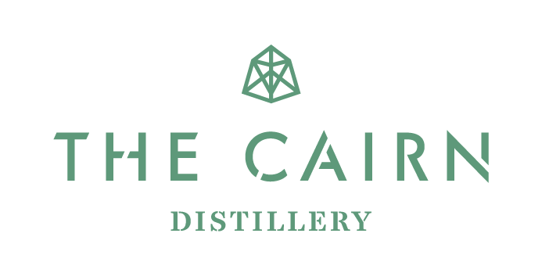
FOOD MENU
All dishes come with a selection of bread and oat cakes with flavoured butter (smoked salt, porchini powder or seaweed powder).

A taste of something different. Each dish has a story to tell, reflecting the people who grew or made it and the place it comes from – served in the Scottish Pintxos style for you to discover and enjoy.

For any Information on dietary requirements, please speak to a member of our team.
V – Vegetarian
VE - Vegan
GF – Gluten Free
DF – Dairy Free
FRESH

Courgette, Mint and Lemon Salad
(V, VE, DF)

Roasted Carrots, Parsley, Lemon, Thyme (V, VE, DF)

Crispy Kale, Chilli and Garlic
(V, VE, DF)

Warm Beaten Tattie Salad (GF)
5.25

5.25

5.25

5.95

CRUNCH & CRUST

White Sourdough (V, VE)
Rye Sourdough (V, VE)
Seeded Crackers
Oatcakes
Three flavour butter

DAIRY

Corra Linn, Rowan Jelly (GF)

Hebridean Blue, Medlar Jelly (GF)

Morangie Brie, Sweet Pickled Red Onions (GF, V)
6.95

6.95

6.95

SMOKED

Smoked Wild Venison Salami, Sweet Pickled Red Onions (GF, DF)

Cold Smoked Venison, Rowan Jelly (GF, DF)

Smoked Mackerel, Turmeric and Raisin Bread and Pickled Onions
12.95

12.95

9.95
CURED

Free-range Pork Rillettes, Cornichons (GF, DF)

Free-range Air-dried Pork Coppa (GF, DF)

Scotch Pie, Squash Ketchup (DF)

Sweet Cured Herrings, Red Cabbage (GF, DF)

7.95

13.95

6.50

7.25

Bread
White sour dough, Rye sour dough and Turmeric and Raisin Bread all locally supplied from the popular KJ's bakery just outside Grantown-on-Spey, freshly made.
Butter
Katy Rodgers artisan butter. With a sprinkling of Seaweed flakes, porcini powder and Scottish sea salt.
Oatcakes
Supplied by J Donald in Portsoy. Traditional Highland oakcakes made with beef lard.
Seeded Crackers
Homemade gluten free crackers with mixed seeds.
Morangie Brie
A classic Scottish brie, made by Highland Fine Cheeses in Tain. Mild and Creamy.
Corra Linn
An unpasteurized hard ewe's cheese from Biggar. Slightly nutty with a chalky note. A Scottish Manchego.
Hebridean blue
Made by the Reade family from the Inner Hebrides. A classic blue cheese, creamy with a little heat.
Warm Beaten Tattie Salad
Made from Scottish potatoes, finished off hardboiled egg, gherkins, capers and mixed herbs.
Roast carrots
Roasted Moray-grown carrots with olive oil, salt, pepper and thyme. Finished with lemon juice and parsley.

The provenance and sustainability of our suppliers is key to our menu. Please ask if you would like any further details about them.

Crispy Kale
Oven roasted kale dressed in chilli, garlic and lemon.
Courgette Salad
Finely sliced courgette with a lemon and chilli dressing.
Scotch Pie
A handmade, hot water crust pie made with mutton mince from Balliefurth Farm, Nethy Bridge.
Cold Smoked Venison
From Inverawe smoke house at the foot of Loch Etive.
Sweet Cured Herring
Orkney sweet cured herring served with pickled red cabbage.
Smoked Mackerel
Also from Inverawe smoke house. Smoked mackerel served on turmeric and raisin bread with mustard mayonnaise and sweet pickled onions.
Rillettes
From Highland Charcuterie. Pork, venison and pheasant confit served with cornichons.
Seasonal Salami
Also from Highland Charcuterie. Beautifully created artisan salami's; Smoked Wild Venison, Beef Pork and Chanterelle, Pork and Fennel.
Coppa
A cured shoulder of Pork, fermented then air-dried, the best Coppa this side of the Dordogne.

